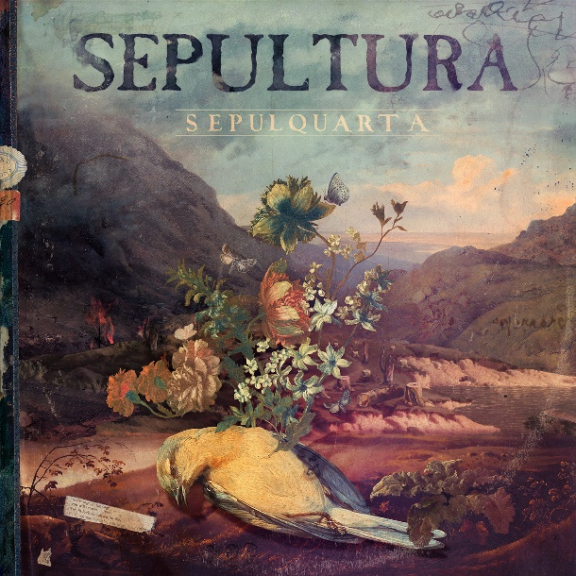

SEPULTURA
»SepulQuarta«

Out August 13th, 2021

Line-up: | SEPULTURA online:
Derrick Green| Vocals  Andreas Kisser | Guitars  Paulo Xisto| Bass  Eloy Casagrande | Drums | www.sepultura.com.br  www.facebook.com/sepultura  www.instagram.com/sepultura  www.twitter.com/sepulturacombr
“In the cage, in the cage you will remain, they lock you down for life”

While the pandemic paralyzed the entire world and prevented bands from touring, Latin America's biggest metal export SEPULTURA refused to sit back and act like an animal trapped in a cage. Like the flowers growing out of the deceased bird’s body depicted on the stunning colourful cover artwork by Eduardo Recife, the thrash metal pioneers from Belo Horizonte made good use of their unexpected free time to start a project that kept them busy throughout the entirety of 2020:

„»SepulQuarta« was born at the very beginning of the pandemic when everything was halted”, guitarist Andreas Kisser remembers. “We had a new album out, but we couldn’t tour for it. Therefore, we created this recurring event where we could talk with our fans around the world, play our music and exchange ideas, it was a blast! »SepulQuarta« kept us alive and strong throughout one of the most difficult times in human history.”

“Doing Sepulquarta during this period allowed me to stay in contact with music. Playing my instrument was the only thing left to do in this pandemic,” adds drummer Eloy Casagrande, and indeed, music seemed to be a good way of coping with the never-ending lockdown and fear of loss and isolation that haunted people worldwide. Obviously, the Brazilian pioneers were not the only musicians feeling this way, so they started to connect with friends and colleagues worldwide and asked them to not only be part of their weekly podcast, but also join them in playing one of SEPULTURA’s classics tracks. From the safety of their homes, international stars like David Ellefson, Scott Ian, Danko Jones, Devin Townsend, Matt Heafy and many more recorded a SEPULTURA track together with the band, which have now been mixed and mastered by Conrado Ruther for release on CD, 2LP and all streaming platforms.

“We invited our amazingly talented friends to be a part of our project, either jamming with us or as a guest in the many Q&A’s we promoted,” Andreas explains. “We talked about our history, music, politics, sports, philosophy, depression and the environment among other things. We learned a lot with specialist guests and many of the great minds of today. Here you will find unique performances of SEPULTURA’s music from the many phases of our career, with amazing guest musicians that lent us their talent and energy to record these historical versions!”

